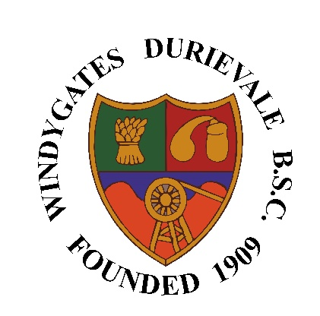
Windygates Durievale
Bowling & Sports Club
Function Hall Booking Form

Name
Address
Postcode
Phone number
Email address
Provide a summary of the reason for hall hire
Date hall is required
Time required
(start and finish time required including set up time if required)
Date of application

Function Hall acceptance is conditional of approval by the Club Committee after application form has been completed and any deposit paid.
Committee approval
Signed |  | Date

Once completed, hand application forms directly in to the club, email to windygatesbc@gmail.com or send by post to: Windygates Durievale Bowling & Sports Club, Leven Road, Windygates, KY8 5DA

